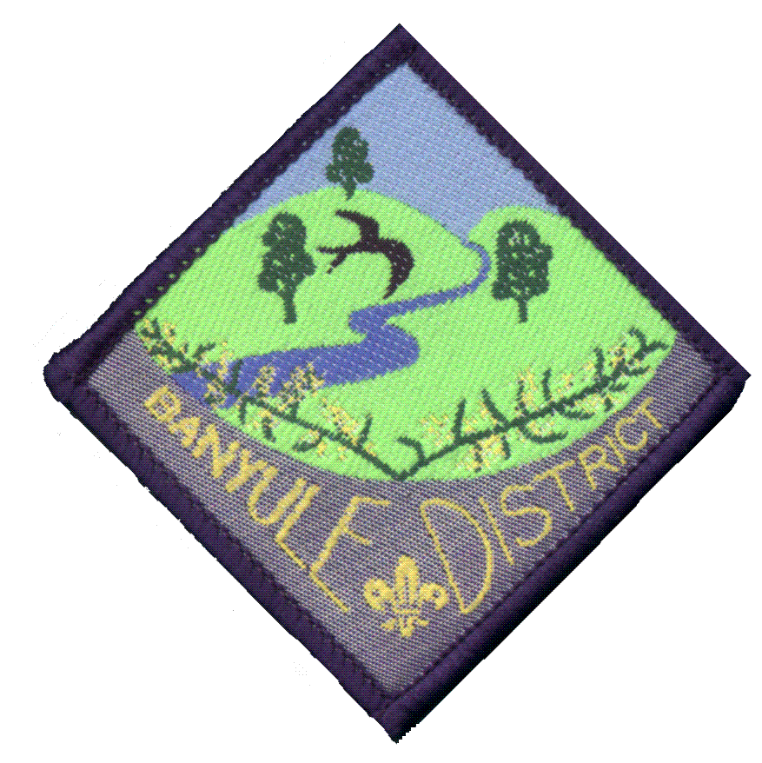
Out Banyule District Cub Scouts
Beach Day
Cost $5.00*
On 6th Dec 2009

Our theme for 2009 is Air & Water
To end this year with our last district event with other Cubs Scouts in the District.
In a fun environment, Cubs meet new friends and learn water safety and survival skills. Participants complete a series of Activities tailored by Dromana Bay Life Saving Club for our Cubs.
All Day Parking

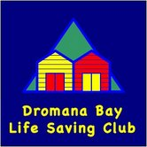
The Day starts 1pm
Meet at Dromana Bay Life Saving Club,
on the beach opposite Dromana Hub Shopping Cent
MELWAY MAP 159-H6
Finishing around 4pm
Dromana Bay Life Saving Club are promoting a healthy and active lifestyle

You will need to bring
Closed in Shoes Sneakers, Water Shoes.
Clothes 1 change, towel, hat, sunscreen, water bottle, Insect Repellent and personal First Aid kit.
Wear your Cub Uniform to Beach Day
PARENTS – PLEASE BRING A SUN SHELTER FOR THE BEACH!
Cut off bottom portion of permission slip and return to your Akela at the Event

I give permission for my child:
Name Group
to take part in the District Beach Day
Enclosed is $5.00 to cover the cost of the refreshments & badge.

Method of payment: ____cash ____ cheque
Note: Please make cheques payable to the Banyule District Cub Scouts.

X
Parent or guardian signature Date

